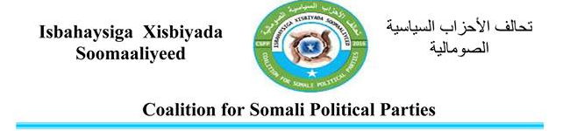

To: Commander Office Of Amisom Troops
Subject: Reporting and billing Date: 10/04/2017
I’m chairman of a coalition Political Parties In Somalia Ali Mohamed Nuh Representative owner Indian Ocean Company in accordance with the letter of agency On 07 / April / 2017 From The Owner Abdi Hosh Ashkir
In respect of the transfer office sheet directly aware that there are complaints, many from people which of Somalia against the forces of civilians claiming compensation different people give as murder Properties pureed and rents the device used troops
Therefore I suggest that giving Somali Citizens Troops claiming compensation
NB-If unresolved complaints from citizens of Somalia before a meeting in London in May / 2017 may be internal and external popular protests over staying Troops in Somalia.
There fore We Propose To Give Somali Cittizens There Claiming Compensation and complaints among residents to an AU forces to demand that the owner of the Indian Ocean Company Abdi Hosh Takes pay rent residences Indian Ocean Company to with in 102Months using sum general $15,300,000 tenancy and followed nearly 10Years According Documents attached to this letter being spent as follows rent has Your mission money to gene Accountability.
THANK YOU
Yours Sincerely Ali Mohamed Nuh
CC: The Office Of The Prime Minister Of The Federal Republic Of Somalia
CC: UK Embassy in Somalia

